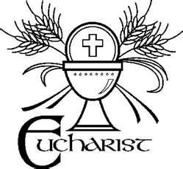
Application for Reception of First Holy Eucharist – May 2, 2015
Please print clearly the information below. Return this
very important form to your child’s IC teacher/IC RE catechist
on or before October 9, 2014.

Full name of child receiving First Eucharist:
First _________________Middle _____________ Last ___________________
Circle One: IC Religious Education OR IC Grade School
Church of Baptism ________________________________
City and State of Baptism ___________________________________
Date of Baptism ___________________________
Date of Birth _____________________________
City and State of Birth _____________________________________
Father’s First Name _______________________________________
Father’s Last Name ________________________________________
Mother’s First Name _______________________________________
Mother’s Last Name _______________________________________
Mother’s Maiden Name _____________________________________
Family Address:
Street ________________________________
City __________________________________
The expectation is that the parents and children participate in the scheduled First Reconciliation and First Eucharist formation events.

